SMART TOURISM AUTOMATION PLATFORM
Workflow Documentation
1. Introduction
The Smart Tourism Automation Platform using AI & n8n is designed to simplify and automate different activities involved in travel planning and management. Traditional travel planning often requires users to handle recommendations, booking information, itineraries, weather updates, and feedback through separate processes. This project brings these activities together using n8n workflow automation, making the overall process more organized and efficient.
The platform consists of multiple independent workflows for customer registration and preferences, AI-based destination recommendations, booking and itinerary management, travel alerts and notifications, and feedback collection and analytics. It uses AI Agent/OpenAI for recommendations and feedback analysis, while services such as Google Sheets, Gmail, Google Calendar, Webhooks, and Weather API are integrated to automate data handling, communication, scheduling, and weather-based updates. The main aim of the project is to reduce manual effort and provide a more personalized and automated travel experience.
2. Problem Analysis
Business Context
The travel and tourism industry involves multiple activities, from understanding customer requirements and suggesting destinations to managing bookings, itineraries, weather updates, and feedback. When these activities are handled manually or through separate systems, they can require more time and effort and may lead to scattered information. The Smart Tourism Automation Platform addresses this by using AI and n8n to connect and automate important travel-related processes in one system.
Key Business Areas
- Customer Management: Collect customer details, preferences, budget, and travel requirements.
- Personalized Travel Planning: Provide destination recommendations based on customer preferences.
- Booking & Itinerary Management: Organize booking details and generate travel itinerary information.
- Travel Alerts: Provide weather-based alerts and travel updates.
- Customer Feedback: Collect feedback and use AI to identify sentiment, satisfaction, issues, and improvements.
- Data Management: Maintain travel-related records in an organized and accessible way.

3. Stakeholders
Customers / Travelers
Customers are the primary users of the Smart Tourism Automation Platform. They provide their travel requirements and preferences, and the system uses this information to support their travel planning and provide relevant services.
The platform helps customers by providing:
- Entering personal and travel preferences.
- Receiving AI-based destination recommendations.
- Getting organized booking and itinerary information.
- Receiving weather-based travel alerts.
- Providing feedback about their travel experience.
Travel Managers / Administrators
Travel managers or administrators can use the platform to manage customer-related travel information and monitor automated travel processes. The system reduces the need for repetitive manual work.
The platform helps them with:
- Managing customer and travel information.
- Organizing booking and itinerary details.
- Accessing customer feedback and AI-generated insights.
- Managing travel-related notifications.
- Reducing manual effort in routine travel operations.
Travel Service Providers
Travel service providers are involved in delivering travel-related services such as accommodation, transportation, and other trip requirements. The platform helps organize the information associated with these services.
They can benefit from:
- Organized booking information.
- Clear customer travel requirements.
- Better access to itinerary details.
- Improved coordination of travel-related information.
System & AI Services
The automation platform itself connects different services to process customer information and generate useful outputs. n8n manages the workflows, while AI services assist with recommendations and feedback analysis.
The system provides:
- Automated workflow execution through n8n.
- AI-powered destination recommendations.
- AI-based customer feedback analysis.
- Automated data storage using Google Sheets.
- Communication through Gmail and scheduling through Google Calendar.
4. Existing Problems and Challenges
Traditional travel planning involves several separate and repetitive activities, which can make the overall process time-consuming and difficult to manage. The major existing problems and challenges are:
- Manual data collection and management of customer details and travel preferences.
- Difficulty in providing personalized recommendations based on budget, interests, and travel requirements.
- Scattered booking and itinerary information across different tools or documents.
- Delayed weather updates and notifications that may affect travel plans.
- Manual processing and analysis of customer feedback.
- Repetitive communication and administrative tasks, such as storing information and sending updates.
- Integration challenges when connecting AI, data storage, email, calendar, and external APIs into one smooth process.
5. Project Objectives
The main objective of the Smart Tourism Automation Platform is to automate important travel-related activities using AI and workflow automation. The system aims to reduce manual effort, organize travel information, and provide a more personalized and efficient experience for customers and travel managers.
The project focuses on the following objectives:
- Automate customer data collection and travel preference management.
- Generate personalized destination recommendations using AI.
- Automate booking and itinerary management for better organization.
- Provide weather-based travel alerts and timely notifications.
- Collect and analyze customer feedback using AI.
- Integrate multiple services such as Google Sheets, Gmail, Google Calendar, and Weather API through n8n.
- Reduce repetitive manual tasks and improve the overall efficiency of travel management.
6. System Architecture
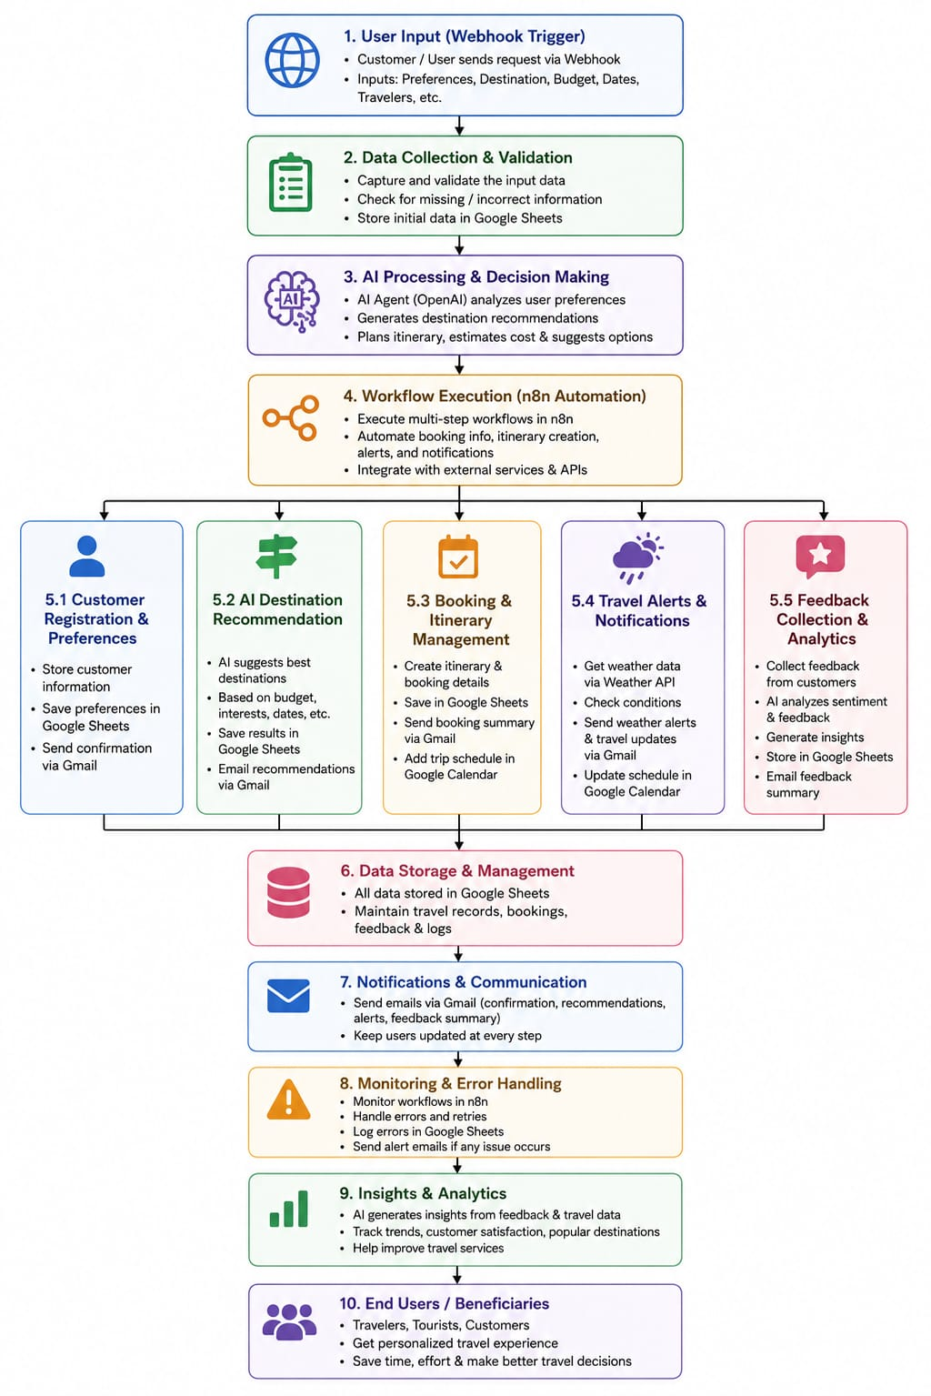
Architecture Explanation
The architecture of the Smart Tourism Automation Platform is divided into multiple layers. Each layer performs a specific role in collecting, processing, storing, and delivering travel-related information.
1. User / Input Layer
This is the starting point of the system where customers provide their travel-related information.
- Customer details and preferences
- Destination and travel requirements
- Booking information
- Customer feedback
2. Trigger / Webhook Layer
The Webhook layer receives the input data and starts the required n8n workflow.
- Receives customer requests
- Triggers the appropriate workflow
- Transfers data to the processing layer
3. Automation / Processing Layer
n8n acts as the main automation layer and controls the flow of data between different services.
- Processes incoming information
- Connects different workflow nodes
- Applies conditions and routing logic
- Passes data between AI, APIs, and other services
4. AI & External API Layer
This layer provides intelligent processing and external information.
- AI Agent / OpenAI: Destination recommendations and feedback analysis
- Weather API: Weather information for travel alerts
- Processes information according to the requirements of each workflow
5. Data Storage Layer
Processed information is stored and organized using Google Sheets.
- Customer information
- Travel preferences
- Booking and itinerary details
- Recommendations
- Feedback and analysis results
6. Communication & Scheduling Layer
This layer handles communication and scheduling with customers.
- Gmail: Sends recommendations, confirmations, alerts and updates
- Google Calendar: Handles travel-related scheduling and calendar events
7. Output Layer
The final layer delivers useful information to the customer or travel manager.
- Personalized recommendations
- Booking and itinerary information
- Weather alerts
- Feedback insights
- Automated email notifications
Overall Flow
User Input → Webhook → n8n Automation → AI/API Processing → Google Sheets → Gmail/Google Calendar → Final Output
7. Workflow Implementation
The Smart Tourism Automation Platform is implemented using n8n, where different independent workflows automate specific travel-related activities. Each workflow starts with a trigger such as a Webhook, processes the received information using workflow logic and AI/API services, and then stores or communicates the generated results through connected services.
7.1 Workflow 1 — Customer Registration & Preferences
Purpose
The purpose of this workflow is to collect and organize customer information and travel preferences at the beginning of the travel planning process. It provides the basic customer data required for further travel-related activities.
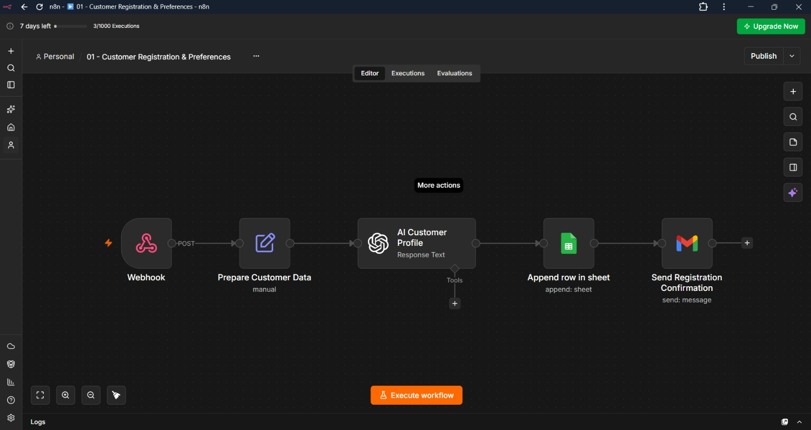

Workflow Flow
Customer Input
↓
Webhook
↓
Data Processing / Mapping
↓
Google Sheets
↓
Gmail Notification
Implementation Details
- The workflow starts with a Webhook that receives the customer's registration and travel preference data.
- The received information is processed and mapped into the required fields.
- Customer details and preferences are stored in Google Sheets for organized record keeping.
- The stored information can be used as input for subsequent travel planning activities.
- Gmail is used to send an automated confirmation/notification after the registration process.
- The workflow is implemented in n8n, which connects the webhook, data processing, Google Sheets, and Gmail nodes into a single automated process.
Key Features
- Webhook-based registration for receiving customer details.
- Travel preference collection including budget, destination, dates, interests, hotel and transport preferences.
- Automatic data organization through field mapping.
- Google Sheets integration for storing customer information.
- Automated Gmail confirmation after successful registration.
- Structured customer data that can be used by subsequent travel workflows.
7.2 Workflow 2 — AI Destination Recommendation
Purpose
The purpose of this workflow is to generate personalized travel destination recommendations based on the customer's travel requirements, preferences, budget, and other details. The workflow uses an AI Agent with OpenAI to process the customer information and generate a suitable recommendation.
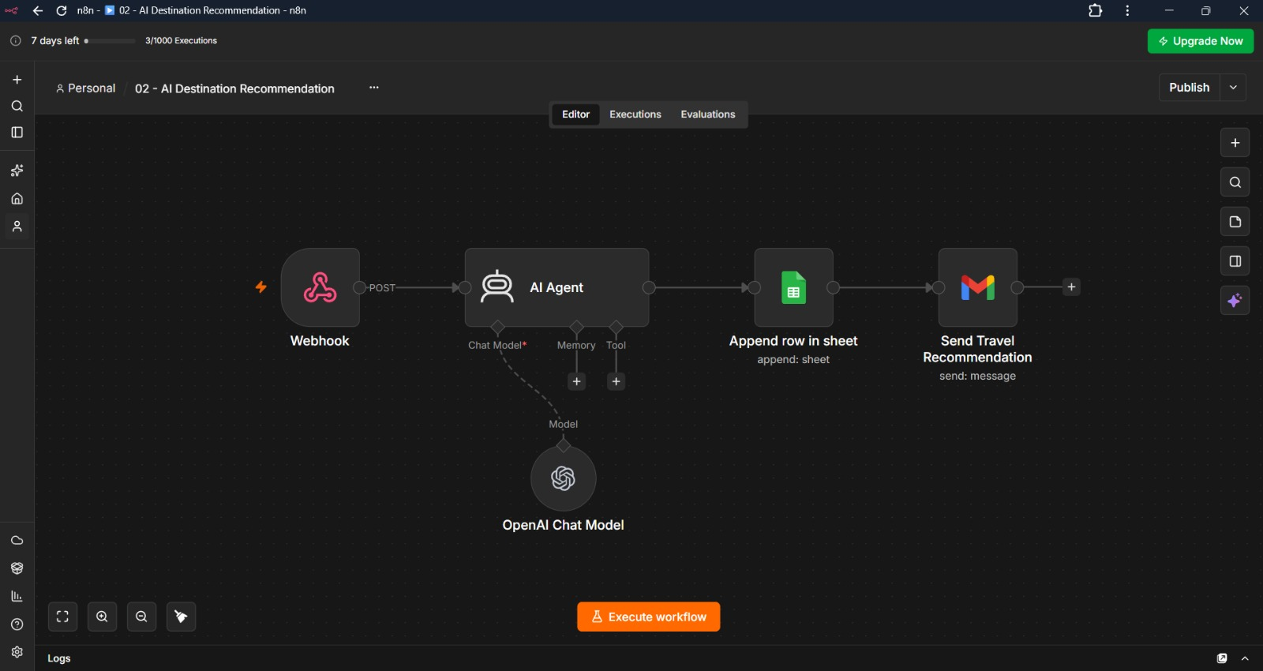

Workflow Flow
Customer Travel Data
↓
Webhook
↓
AI Agent
↓
OpenAI Chat Model
↓
Recommendation Output
↓
Google Sheets
↓
Gmail
Implementation Details
- The workflow starts with a Webhook that receives the customer's travel information.
- The received data is passed to the AI Agent for processing.
- The AI Agent uses the OpenAI Chat Model to generate a personalized travel recommendation.
- The recommendation is based on information such as destination, budget, travelers, travel dates, interests, hotel preference, and transport preference.
- The generated recommendation is stored in Google Sheets along with the relevant customer information.
- Gmail sends the recommendation to the customer.
- n8n manages the complete flow and connects the AI, storage, and communication services.
Key Features
- AI-powered destination recommendations
- Personalized suggestions based on customer preferences
- Budget-aware travel planning
- OpenAI integration through the AI Agent
- Automatic storage of recommendations in Google Sheets
- Automated Gmail delivery of the recommendation
7.3 Workflow 3 — Booking & Itinerary Management
Purpose
The purpose of this workflow is to manage customer booking information and generate travel itinerary details based on the customer's destination, travel dates, number of travelers, booking type, hotel, room type, transport and budget.
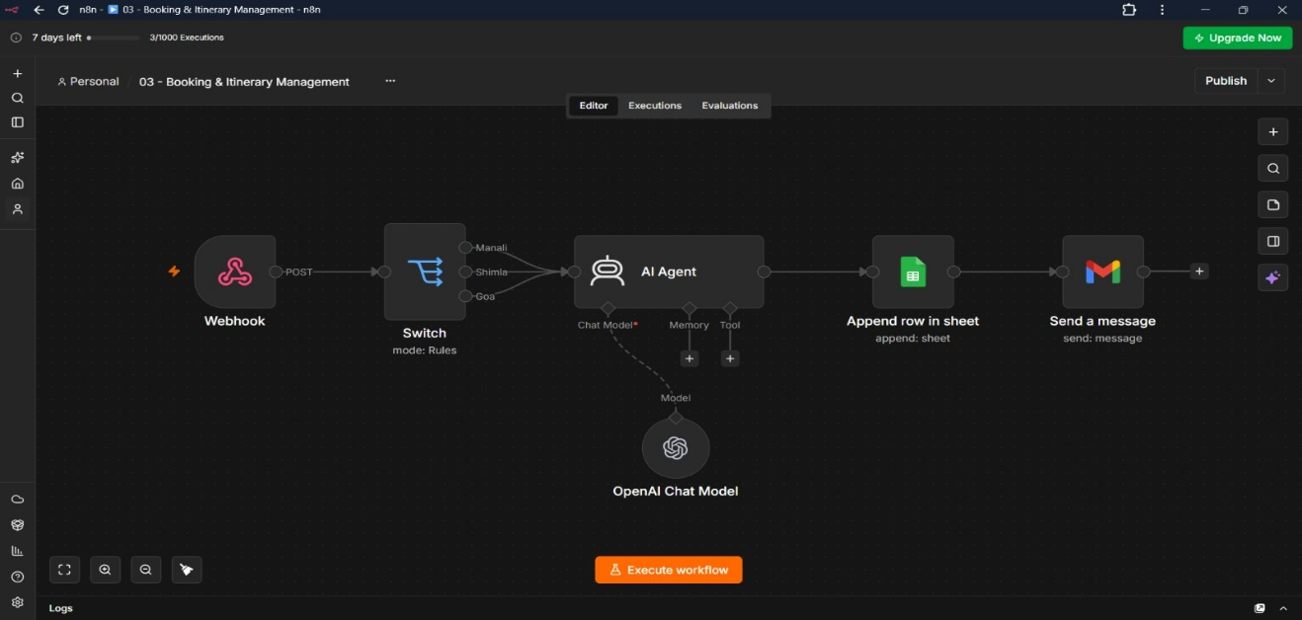
Workflow Flow
Booking Request
↓
Webhook
↓
Destination-based Switch / Routing
↓
AI Agent
↓
Google Sheets
↓
Gmail
Implementation Details
- The workflow starts with a Webhook that receives the customer's booking and travel details.
- A Switch node routes the request according to the selected destination.
- The request is then passed to the AI Agent to process the booking-related information and generate itinerary details.
- The workflow handles details such as customer ID, destination, travelers, start date, end date, booking type, hotel, room type, transport and budget.
- Booking and itinerary information is stored in Google Sheets for organized record keeping.
- Gmail is used to communicate the generated booking/itinerary information.
- The complete process is controlled through n8n, allowing the booking workflow to run automatically.
Key Features
- Webhook-based booking request handling
- Destination-based routing
- AI-assisted itinerary generation
- Hotel, room and transport information management
- Booking and itinerary data storage in Google Sheets
- Automated Gmail communication

7.4 Workflow 4 — Travel Alerts & Notifications
Purpose
The purpose of this workflow is to provide timely weather-based travel alerts and notifications to customers. It uses the customer's travel details along with weather information to identify relevant conditions and communicate updates.
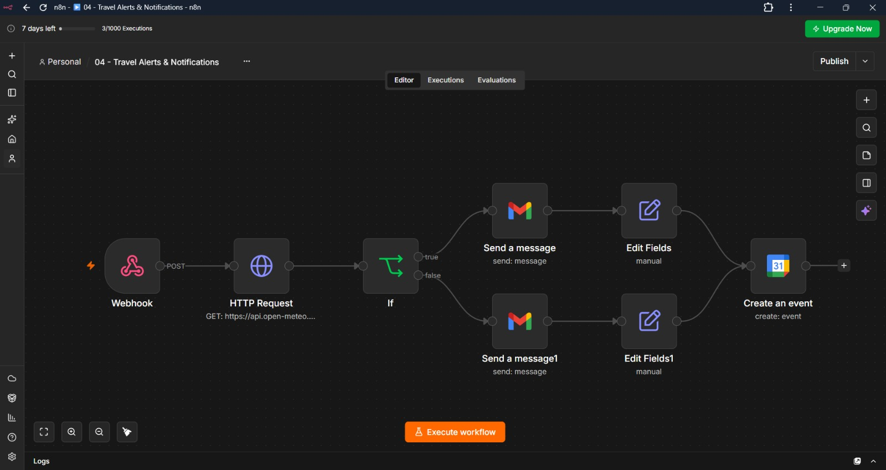
Workflow Flow
Travel Details / Webhook
↓
Weather API
↓
Weather Data Processing
↓
Condition Check
↓
Alert / Notification Generation
↓
Gmail + Google Calendar
Implementation Details
- The workflow receives travel-related information through a Webhook.
- The destination and relevant travel information are used to obtain weather information through the Weather API.
- The received weather data is processed within the n8n workflow.
- A condition check determines the appropriate notification based on the weather condition.
- The workflow prepares a travel-related alert or update for the customer.
- Gmail is used to send the weather notification.
- Google Calendar is used for the relevant travel scheduling information.
- n8n coordinates the complete process between the Webhook, Weather API, condition logic, and communication services.
Key Features
- Webhook-based travel alert trigger
- Weather API integration
- Weather condition checking
- Automated travel notifications
- Gmail integration for alerts
- Google Calendar integration for scheduling
7.5 Workflow 5 — Feedback Collection & Travel Analytics
Purpose
The purpose of this workflow is to collect customer feedback and analyze it using AI. It converts the customer's rating and written feedback into useful insights that can help understand satisfaction and identify areas for improvement.
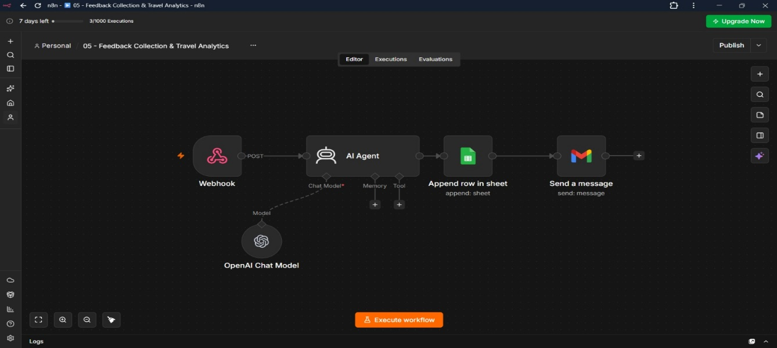
Workflow Flow
Customer Feedback
↓
Webhook
↓
AI Agent
↓
Feedback Analysis
↓
Google Sheets
↓
Gmail
Implementation Details
- The workflow starts with a Webhook that receives customer feedback.
- The input includes information such as Customer ID, Email, Destination, Rating, and Feedback.
- The feedback is passed to the AI Agent for analysis.
- The AI processes the written feedback and generates useful feedback insights.
- The analyzed information is stored in Google Sheets for future reference and analytics.
- Gmail is used to send an automated message based on the workflow output.
- The complete process is automated using n8n.
Key Features
- Webhook-based feedback collection
- AI-powered feedback analysis
- Customer rating and review processing
- Google Sheets integration for storing feedback
- Automated Gmail communication
- Useful insights for understanding customer satisfaction
8. Technology Stack
The project combines workflow automation, artificial intelligence, cloud-based services, and external APIs to create an automated tourism management system.

1. n8n – Workflow Automation Platform
n8n is the main automation platform used to design and execute the five workflows of the project. It acts as the central layer that connects Webhooks, AI services, Google services, and external APIs. Each workflow is built using connected nodes that process information step by step.
Key Functions:
- Creates and executes independent tourism workflows.
- Connects different applications and services.
- Handles data processing, mapping, conditions, and routing.
- Automates repetitive travel-related tasks.
- Controls the complete flow from input to final output.
2. OpenAI & AI Agent – Artificial Intelligence
OpenAI is integrated with the n8n AI Agent to provide intelligent processing in the system. It is mainly used where the workflow needs to understand customer requirements, generate personalized recommendations, or analyze written feedback.
Key Functions:
- Generates personalized destination recommendations.
- Processes customer travel preferences.
- Analyzes customer feedback.
- Generates useful feedback insights and summaries.
- Supports AI-based processing within n8n workflows.
3. Webhooks – Workflow Trigger
Webhooks are used as the input mechanism for the workflows. They allow external requests containing customer or travel information to enter n8n and automatically start the corresponding workflow.
Key Functions:
- Receives customer and travel-related data.
- Starts the required n8n workflow.
- Transfers input data to the processing nodes.
- Supports event-based workflow execution.
- Acts as the entry point for multiple workflows.
4. Google Sheets – Data Storage
Google Sheets is used as the main storage and record-keeping service in the project. Information generated or processed by the workflows is stored in structured rows and columns, making the travel data easier to maintain and access.
Key Functions:
- Stores customer registration details.
- Maintains travel preferences and booking information.
- Stores AI-generated recommendations.
- Records customer feedback and analysis.
- Keeps workflow outputs organized for future reference.
5. Gmail – Communication
Gmail is integrated into the workflows to automate communication with customers. Instead of manually sending every update, the workflow can generate and send emails when the required processing is completed.
Key Functions:
- Sends destination recommendations.
- Sends booking and itinerary information.
- Delivers weather-related alerts.
- Sends feedback-related messages.
- Automates routine customer communication.
6. Google Calendar – Scheduling
Google Calendar is used to manage travel-related scheduling information within the automation system. It helps connect travel activities with calendar-based planning and keeps important schedule information organized.
Key Functions:
- Manages travel-related schedule information.
- Supports calendar-based planning.
- Helps organize important travel dates.
- Integrates scheduling with the automated workflow.
7. Weather API – External Data Service
The Weather API provides weather information used by the Travel Alerts & Notifications workflow. The workflow requests weather information for the relevant travel location and uses the returned data to determine the appropriate travel notification.
Key Functions:
- Retrieves weather information for travel destinations.
- Provides weather data to the n8n workflow.
- Supports weather-condition checking.
- Helps generate weather-based travel alerts.
- Enables more timely travel updates.
9. AI Integration & Intelligent Features
AI is an important part of the Smart Tourism Automation Platform, as it adds intelligent processing to the automated workflows. The project uses AI to understand customer requirements, generate personalized travel recommendations, and analyze customer feedback. The AI functionality is integrated with n8n, allowing the intelligent output to be automatically passed to other services such as Google Sheets and Gmail.
9.1 OpenAI Integration
OpenAI is integrated into the n8n workflows through the AI Agent and OpenAI Chat Model. It is mainly used in the destination recommendation and feedback analysis workflows, where customer information or written feedback needs to be understood and processed before generating an output.
Capabilities of OpenAI Integration
- Understanding Customer Requirements: Processes information such as travel preferences, budget, interests, destination, dates, and other requirements.
- Personalized Recommendations: Generates destination recommendations according to the customer's provided information.
- Natural Language Processing: Understands written customer feedback and converts it into meaningful information.
- Feedback Analysis: Processes ratings and written reviews to identify useful feedback insights.
- Context-Based Output: Generates responses according to the information received from the current workflow.
- Integration with n8n: AI-generated results can be passed to subsequent workflow nodes for storage or communication.
9.2 Intelligent Features
The intelligent features of the platform use AI to perform tasks that require understanding and interpretation rather than simple data transfer. The AI Agent works with n8n automation to make the travel process more personalized and useful for customers.
Key Intelligent Features
1. Personalized Destination Recommendation
The system analyzes customer preferences, budget, interests, travel dates, and other requirements to generate a suitable travel recommendation.
2. AI-Based Feedback Analysis
Customer ratings and written feedback are processed by the AI to extract meaningful information and help identify customer satisfaction and areas for improvement.
3. Natural Language Understanding
The system can process customer-provided text and understand the relevant information required by the workflow.
4. Context-Aware Response Generation
The AI generates responses based on the customer information received rather than relying only on predefined responses.
5. AI-Assisted Workflow Automation
n8n manages the overall workflow execution, while the AI Agent handles the intelligent processing. This combination reduces repetitive manual work and adds intelligent decision support to the automation process.
10. Workflow integration and data flow
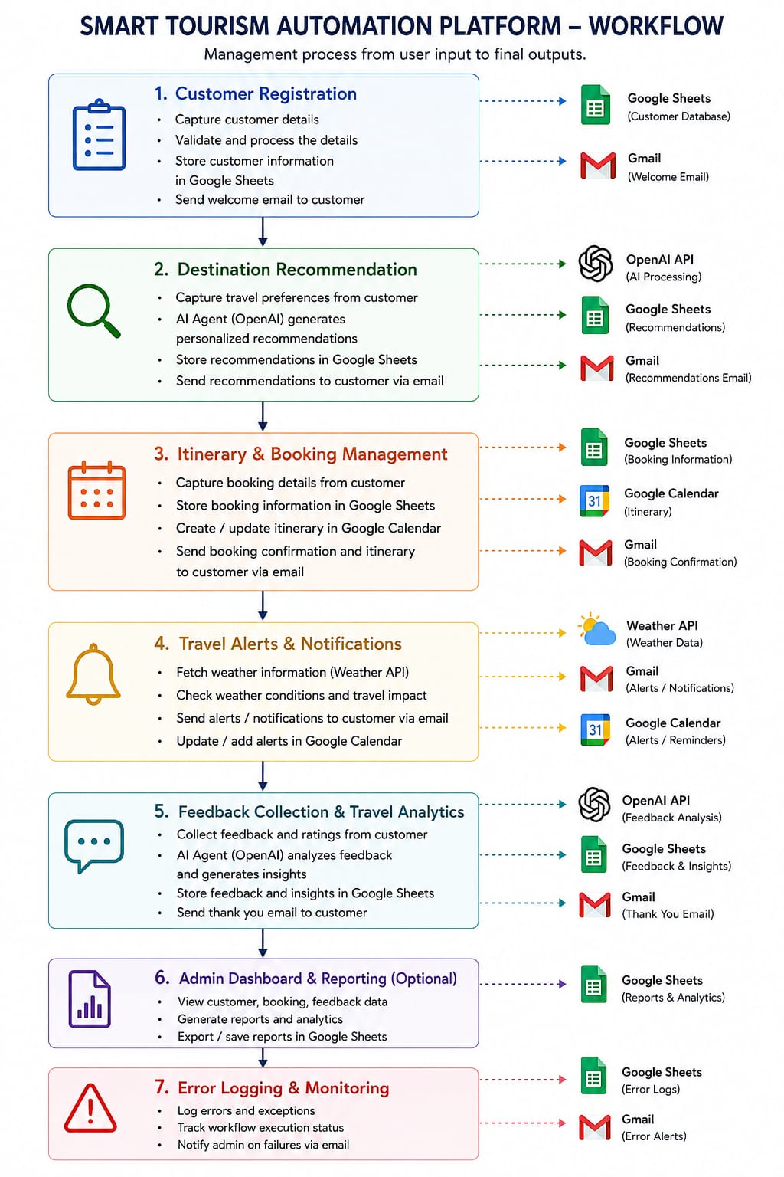
The Workflow Integration and Data Flow illustrates how different n8n workflows communicate and exchange data to automate the complete process from user input to final output.
11. Advanced Features Implemented
The Smart Tourism Automation Platform includes several advanced features that make the system more reliable, intelligent, and efficient. These features are implemented using n8n workflow logic along with AI, APIs, Google services, and automated communication. They help the platform handle different customer requirements while reducing manual intervention.
11.1 AI-Powered Personalization
The platform uses the AI Agent with OpenAI to generate travel recommendations according to individual customer preferences instead of providing the same recommendations to every user.
Key Features:
- Personalized destination recommendations.
- Preference-based AI processing.
- AI-generated travel suggestions.
- Customer feedback analysis.
11.2 Automated Workflow Integration
Multiple services are connected through n8n, allowing information to move automatically between different stages of the tourism process.
Key Features:
- Webhook-based workflow triggering.
- Integration with Google Sheets, Gmail, Calendar and APIs.
- Automatic data transfer between workflow nodes.
- Independent workflows for different tourism activities.
11.3 Automated Notifications & Alerts
The system automatically communicates important information to customers through Gmail and uses weather information for travel alerts.
Key Features:
- Automated confirmation emails.
- Personalized recommendation emails.
- Weather-based travel alerts.
- Booking and itinerary notifications.
- Automated feedback/thank-you emails.
11.4 Weather-Based Travel Monitoring
The platform integrates a Weather API to obtain weather information for the customer's destination and uses workflow conditions to determine whether an alert or update is required.
Key Features:
- Real-time weather data retrieval.
- Weather condition checking.
- Travel-impact based alerts.
- Calendar-based reminders and updates.
11.5 Centralized Data Management
Google Sheets is used to maintain structured records generated across the different workflows, making the information easier to access and manage.
Key Features:
- Centralized customer data.
- Booking and itinerary records.
- Destination recommendations.
- Feedback and analytics data.
- Organized workflow outputs.
11.6 Error Logging & Monitoring
The workflows include error-handling and monitoring mechanisms to identify failures during workflow execution and maintain proper records.
Key Features:
- Error and exception tracking.
- Workflow execution monitoring.
- Error logging in Google Sheets.
- Automated failure notifications through Gmail.
11.7 Modular Workflow Design
The platform is divided into separate workflows for registration, recommendations, booking, alerts, and feedback. This modular approach makes the system easier to manage and modify.
Key Features:
- Independent workflow execution.
- Easier testing and debugging.
- Flexible integration of new services.
- Better scalability and maintenance

12. Testing and Validation
Testing and validation were performed separately for all five workflows to verify that the provided input was correctly processed and that the expected output was generated.
12.1 Customer Registration & Preferences
Input
Sample customer details including name, email, phone number, destination, travel dates, budget, interests, hotel preference, transport preference, and number of travelers were submitted through the Webhook.
Expected Output
The workflow should process the customer information, store the details in Google Sheets, and trigger an automated Gmail confirmation/notification.
Result
Passed. The customer information was successfully received, processed, stored in Google Sheets, and the required Gmail notification was triggered.
12.2 AI Destination Recommendation
Input
Customer travel preferences including destination requirements, budget, interests, travel dates, hotel preference, transport preference, and number of travelers were provided through the workflow.
Expected Output
The AI Agent with OpenAI should analyze the provided information and generate a personalized destination recommendation. The generated recommendation should then be stored in Google Sheets and communicated through Gmail.
Result
Passed. The customer information was successfully processed by the AI Agent, a personalized recommendation was generated, and the output was passed to the storage and communication stages.
12.3 Booking & Itinerary Management
Input
Booking details including customer ID, destination, number of travelers, start date, end date, booking type, hotel, room type, transport, and budget were provided through the Webhook.
Expected Output
The workflow should process the booking request, route the information according to the destination, generate the required itinerary/booking information, store the details in Google Sheets, and send the relevant information through Gmail.
Result
Passed. The booking information was successfully received and processed, with the expected data being stored and the communication stage executed successfully.
12.4 Travel Alerts & Notifications
Input
Travel destination and relevant travel-date information were provided to the workflow so that weather information could be checked for the trip.
Expected Output
The Weather API should provide the required weather information. The workflow should process the weather condition and generate the appropriate travel alert or notification through Gmail, with the relevant scheduling information handled through Google Calendar.
Result
Passed. Weather information was successfully retrieved and processed, and the required travel notification flow was executed.
12.5 Feedback Collection & Travel Analytics
Input
Customer feedback containing customer ID, email, destination, rating, and written feedback was submitted through the Webhook.
Expected Output
The AI Agent should analyze the feedback and generate useful insights. The analyzed feedback should be stored in Google Sheets, followed by the required Gmail communication.
Result
Passed. The feedback was successfully received and processed by the AI Agent, the analysis was stored in Google Sheets, and the communication stage was executed successfully.
Overall Validation
All five workflows were tested using sample inputs and validated by checking the complete Input → Processing → Output flow. The testing confirmed that the major workflow components, AI integration, data storage, API integration, email communication, and scheduling services worked according to their intended functionality.

13. Future Enhancements
The current Smart Tourism Automation Platform provides the basic automation required for travel planning, but it can be further enhanced with more advanced integrations and intelligent capabilities.
Live Booking Integration: Integrate real-time hotel, flight, and transport booking APIs to allow actual reservations.
Advanced AI Trip Planning: Improve the AI Agent to generate complete day-wise itineraries based on budget, interests, duration, and preferences.
Real-Time Notifications:
Add live flight, hotel, traffic, and weather updates for better travel assistance.
Advanced Analytics Dashboard: Develop a dashboard to visualize customer preferences, bookings, ratings, feedback, and travel trends.
Human Approval Mechanism: Add an approval step before important actions such as bookings or major itinerary changes.
Error Handling & Retry: Implement stronger error-handling and automatic retry mechanisms for failed API calls or workflow executions.
Multi-Destination Support: Extend the platform to handle multiple destinations and complex multi-city trips.
Mobile Application: Develop a mobile interface through which customers can submit requests, receive recommendations, and track their travel plans.
14.Project Outcomes
- Successfully automated major travel-related activities using n8n workflows.
- Automated customer registration and travel preference collection.
- Generated personalized destination recommendations using OpenAI and AI Agent.
- Automated booking and itinerary information management.
- Implemented weather-based travel alerts and notifications using Weather API.
- Automated customer feedback collection and AI-based analysis.
- Integrated Google Sheets for centralized data storage and record management.
- Integrated Gmail for automated customer communication.
- Integrated Google Calendar for travel-related scheduling.
- Reduced repetitive manual effort through workflow automation.
- Demonstrated effective integration of AI, APIs, Webhooks, and cloud services in a tourism application.
- Created a modular and extensible platform that can be further enhanced with live booking APIs, advanced analytics, and real-time travel services.
Conclusion
The Smart Tourism Automation Platform using AI & n8n successfully demonstrates how workflow automation and artificial intelligence can be combined to simplify different travel-related activities. The project automates customer registration, personalized destination recommendations, booking and itinerary management, weather-based alerts, and customer feedback analysis through five dedicated workflows.
By integrating n8n, OpenAI/AI Agent, Webhooks, Google Sheets, Gmail, Google Calendar, and Weather API, the system reduces repetitive manual work and provides a more organized and personalized travel management process. The modular architecture also makes the platform flexible for future improvements such as live booking services, advanced analytics, real-time travel updates, and enhanced AI-based trip planning.

